**ST.XAVIER’S COLLEGE**

MAITIGHAR, KATHMANDU



Computer Graphics

Assignment #8

Submitted By:

Aabhash Dhakal

013BSCCSIT001

2nd year/ 4th semester

Submitted to:

|  |  |
| --- | --- |
| Er. Anil K. Sah  Lecturer  Department of Computer Science |  |

**STATEMENT**

Write a program to translate an image in C++ builder.

­**ALGORITHM**

**Reflection on X axis**

Step 1: Set x= Image1->Height;

Set y = Image1->Width;

Step 2: For i = 1 to x

For j = 1 to y

Set a = x - 1

b =j

Image2->Canvas->Pixels[a][b] = Image1->Canvas->Pixels[i][j];

Step 4: End

**Reflection on Y axis**

Step 1: Set x= Image1->Height;

Set y = Image1->Width;

Step 2: For i = 1 to x

For j = 1 to y

Set a = x

b =j - y

Image2->Canvas->Pixels[a][b] = Image1->Canvas->Pixels[i][j];

Step 4: End

**SOURCE CODE**

//---------------------------------------------------------------------------

#include <vcl\vcl.h>

#pragma hdrstop

#include "ref.h"

//---------------------------------------------------------------------------

#pragma resource "*.dfm"

TForm1 *Form1;

int a, b, i, j, x, y;

//---------------------------------------------------------------------------

__fastcall TForm1::TForm1(TComponent* Owner)

: TForm(Owner)

{

}

//---------------------------------------------------------------------------

void __fastcall TForm1::Button1Click(TObject *Sender)

{

x = Image1->Height;

y = Image1->Width;

for(i=0;i<=x;i++)

{

for(j=0;j<=y;j++)

{

a=x-i;

b=j;

Image2->Canvas->Pixels[a][b] = Image1->Canvas->Pixels[i][j];

}

}

}

//---------------------------------------------------------------------------

void __fastcall TForm1::Button2Click(TObject *Sender)

{

int x = Image1->Height;

int y = Image1->Width;

for(i=0;i<=x;i++)

{

for(j=0;j<=y;j++)

{

a=i;

b=y-j;

Image3->Canvas->Pixels[a][b] = Image1->Canvas->Pixels[i][j];

}

}

}

//---------------------------------------------------------------------------

//---------------------------------------------------------------------------

**OUTPUT SCREENS**

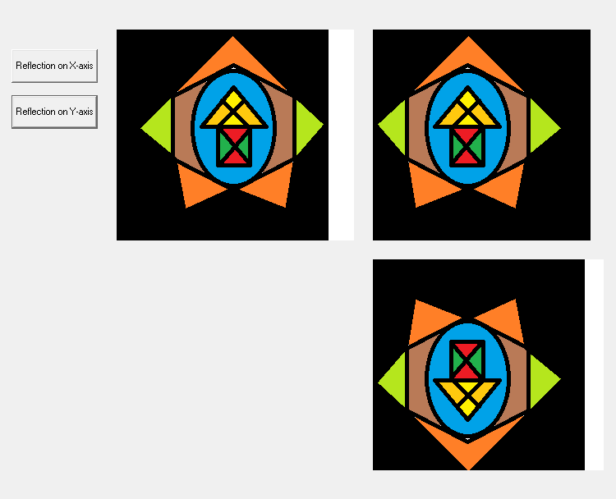

**CONCLUSION**

Hence, a program to translate an image in C++ builder was written and implemented.